**Homework #16, Judy Minichelli**

27Nov2017 Data 520 Introduction to Programming

**Gries 16.8 1, 4, 5 (format to 1 decimal place)**

**1.**

import tkinter

window = tkinter.Tk()

frame = tkinter.Frame(window)

frame.pack()

button = tkinter.Button(frame, text='Goodbye', command=lambda: window.destroy())

button.pack()

window.mainloop

RESTART: C:/Users/Judy/AppData/Local/Programs/Python/Python36-32/hwch16_1.py

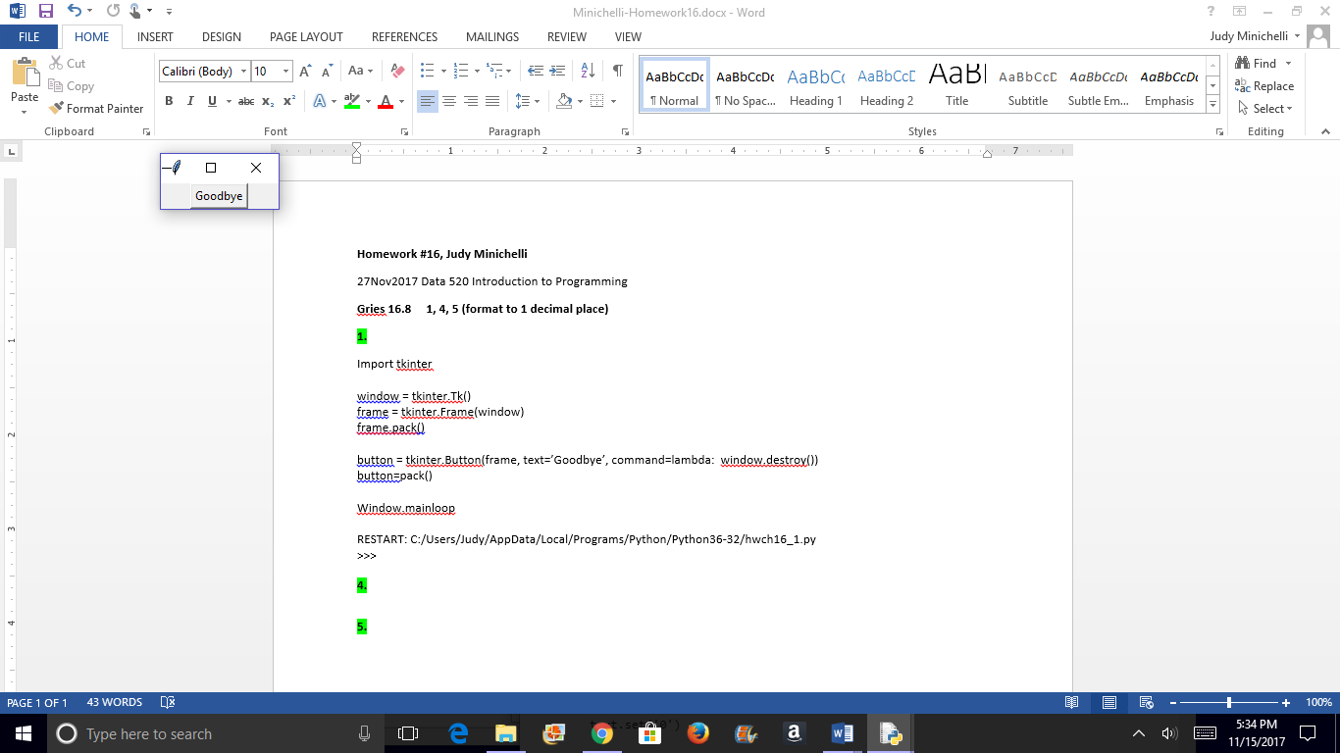

**4.**

import tkinter

def count(text, out_data):

""" Update out_data with the total number of As, Ts, Cs, and Gs found in text."""

data = text.get('0.0', tkinter.END)

counts = {}

for char in 'ATCG':

counts[char] = data.count(char)

out_data.set('Num As: {0} Num Ts: {1} Num Cs: {2} Num Gs: {3}'.format(counts['A'], counts['T'], counts['C'], counts['G']))

window = tkinter.Tk()

frame = tkinter.Frame(window)  *#Re: online solution - I added this to correct the frame error*

frame.pack() *#Re: online solution - I added this to correct the frame error*

text = tkinter.Text(window, height=5, width=30)

text.pack()

out_data = tkinter.StringVar()

button = tkinter.Button(frame, text='Count', command=lambda: count(text, out_data))

button.pack()

label = tkinter.Label(window, textvar=out_data)

label.pack()

window.mainloop()

= RESTART: C:/Users/Judy/AppData/Local/Programs/Python/Python36-32/Ch16_4.py =

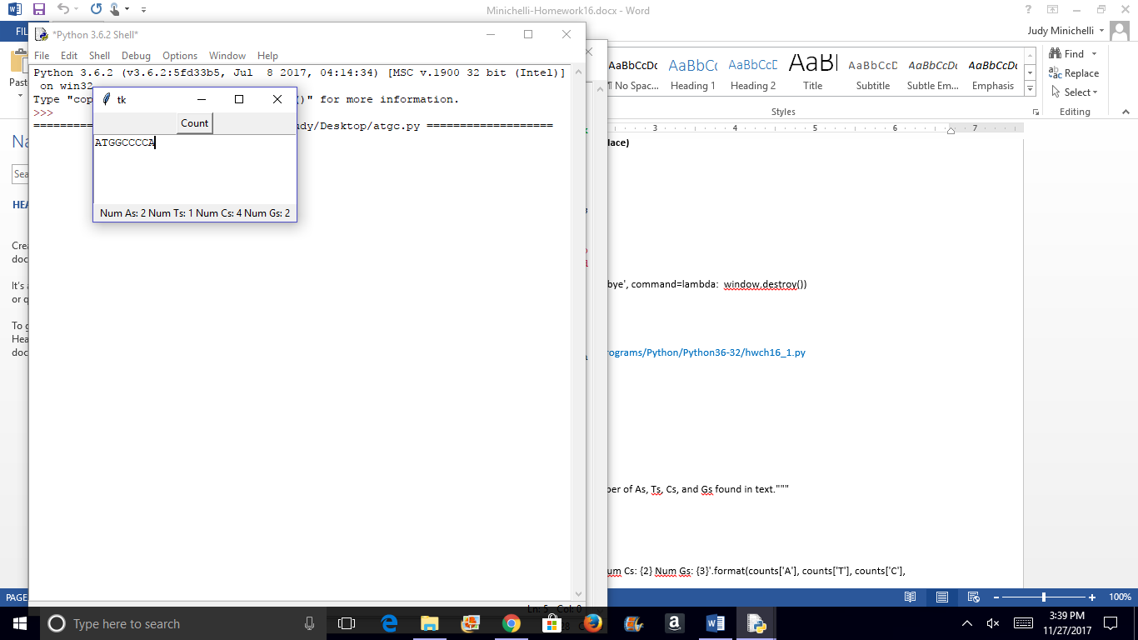

**5.** format to 1 decimal point

import tkinter

def convert(out_data, temp_data):

""" Convert the value in temp_data, assumed to be in degrees Celsius,

to Fahrenheit and store the result in out_data. """

f = temp_data.get()

out_data.set(round((f - 32) * 5 / 9,1))

window = tkinter.Tk()

frame = tkinter.Frame(window)

frame.pack()

out_data = tkinter.StringVar()

temp_data = tkinter.DoubleVar()

tkinter.Label(frame, text='Temperature in Fahrenheit:').pack()

text = tkinter.Entry(frame, textvar=temp_data)

text.pack()

label = tkinter.Label(frame, textvar=out_data)

label.pack()

button = tkinter.Button(frame, text='Convert', command=lambda: convert(out_data, temp_data))

button.pack()

button2 = tkinter.Button(frame, text='Quit', command=lambda: window.destroy())

button2.pack()

window.mainloop()

RESTART: C:/Users/Judy/AppData/Local/Programs/Python/Python36-32/Hwp337_6.py

